- Bring several small primed canvases (roughly 12" x 16") to first class for quick studies. They can be 1) stretched, 2) canvas panels or 3) unstretched sheets of canvas that can be taped on a board(board and tape not provided).

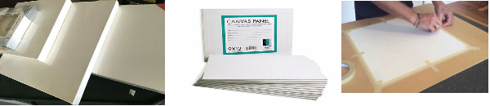

Whichever option you choose, please prepare your canvases by toning them with a light grey or any neutral color. It doesn't have to be evenly applied, just has to cover the whole canvas.

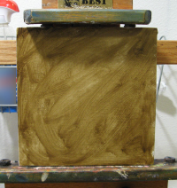

2. Colors: (Acrylic/Oil):

Titanium White
Alizarin Crimson
Permanent Rose
Cadmium Red Light (or Cadmium Scarlet from Winsor Newton)
Cadmium Red
Cadmium Orange
Cadmium Yellow
Lemon Yellow
Permanent Green Light (or Brilliant Green from Utrecht)
Phthalo Green
Cobalt Blue
Dioxazine Purple
Raw Umber

For those of you who are just starting and want to save cost on oil paint, Dickblick sells low cost oil paint that is decent for learning. But they don't have all of the colors on the list.

3. Brushes: try to get some hog bristle (natural bristle is better than synthetic) brushes from size 1 to size 8. Filbert is the preferred style. A few small sable brushes are nice for details but not a must. Big sable brushes are expensive and unnecessary for this class.

4. Paint thinner: If you are painting in oils, please bring ODERLESS paint thinner only, such as Turpenoid. For acrylic painters, it is strongly recommended that you use retarder which slows down drying.

5. Paper towels or rags to wipe off paint with. The blue shop paper towels are very good and inexpensive. You can find them in Home Depot or Costco.

